4.Proposed Approach:

4.1 Problem Complexity and Motivation
The problem of forming optimal k-anonymous clusters on quasi-columns is a known NP-hard problem, particularly when the data contains both categorical and numerical attributes. The current state of anonymization solutions is based on aggressive approaches such as full Lowest Common Ancestor (LCA) generalization or top-down partitioning. While these approaches meet privacy goals, they also cause significant loss of information, resulting in low data utility.
In clustering-based anonymization solutions, the focus has been on numerical distance measures, with categorical attributes either considered independently or generalized using coarse-grained generalization. This has led to a neglect of the semantic structure present in categorical domains, even when Domain Generalization Hierarchies (DGHs) are available. Further, the inclusion of semantic clustering in current solutions has been hampered by poor scalability and high computational costs, making these solutions unsuitable for large datasets.
The major deficiency in current literature is the lack of a data-structure-driven semantic clustering solution that considers both semantic preservation and scalability. Current solutions do not benefit from optimized algorithm design or efficient data structures such as HashMaps, PriorityQueues, two-pointer methods, and bounded recursion to facilitate scalable clustering over multiple categorical attributes.

4.2 Overview of the Proposed Approach
To address the shortcomings of the existing approaches, we propose a level-wise semantic clustering framework for k-anonymization that is specifically designed with optimized data structures and algorithms. Our framework supports clustering based on combinations of categorical attributes, allowing for semantically meaningful clusters, and optimizes numerical attributes within each categorical cluster, rather than using them to guide the clustering process.
The proposed framework combines the following components:
• HashMaps for efficient grouping of tuples based on combinations of categorical attributes,
• PriorityQueues (min-heaps) for organizing numerical attributes in each semantic cluster,
• Two-pointer approaches for distinguishing finalized clusters from unprocessed tuples in-place, and
• Recursion for facilitating controlled level-wise generalization over Domain Generalization Hierarchies (DGHs).
By leveraging all these components together, our framework has a time complexity of O(n log n) for each anonymization step. Since the level-wise generalization depth is limited by the maximum height of the DGHs, which is independent of the dataset size, the overall complexity remains at O(n log n). This makes our proposed approach scale well to large datasets with up to 10⁶ records, as validated by our complexity analysis and experimental results.

4.3 Design Principles of the Proposed Approach

4.3.1 Semantic Clustering Based on Categorical Attribute Combinations
The proposed framework uses a level-wise generalization approach for categorical Domain Generalization Hierarchies (DGHs). In the first iteration, clustering is done based on the original (level-0) categorical attributes. In the remaining iterations, clustering is done based on increasingly general categorical attributes (level-1, level-2, and so on), as informed by the modified boundary pointer from the previous iteration.
At each level, the algorithm favors sibling-based clustering, where categorical attributes having the same immediate parent in the DGH are grouped first. This approach guarantees (i) minimal loss of categorical information, (ii) high semantic interpretability, and (iii) efficient clustering formation at the current generalization level.
The proposed framework allows early termination when sufficient sibling frequencies are collected at lower levels, preventing unnecessary generalization at higher levels of the DGH. Early termination maintains data utility while meeting k-anonymity requirements.
The major contribution of the proposed solution does not lie in semantic clustering alone but in showing that semantic clustering on categorical combinations can be made scalable and feasible with a greedy and data-structure-optimized approach. The proposed framework integrates semantic reasoning from DGHs with efficient algorithmic solutions, which is a combination not considered in existing anonymization techniques.
In contrast to distance-driven methods, clustering is done first on combinations of categorical attributes, and then optimization of numerical attributes happens within each semantic group. For instance:
doctor + 243** + UG → { {age=24, salary=75k}, {age=34, salary=65k} }*
In this case, designation, pincode, and education are the categorical combination, and age and salary are the numerical attributes. These clusters are semantically meaningful (for instance, “graduates working as doctors in a certain region”), and privacy preservation can be achieved with little generalization of the categorical attributes and careful anonymization of the numerical attributes.

4.3.2 Sibling-First Generalization Strategy
All categorical features are linked with pre-defined Domain Generalization Hierarchies (DGHs). The proposed approach adopts a sibling-first strategy for generalization, where all categorical values having the same immediate parent in the DGH are generalized before their common ancestors.
This approach maintains semantic consistency, reduces the loss of categorical information, and prevents over-generalization at a coarse level of LCAs or roots. Consequently, the most accurate clusters at a given level of generalization are obtained in each iteration.

4.3.3 Level-Wise Generalization over DGHs
The clustering algorithm runs iteratively over the levels of the DGH:
• Level 0: Original categorical values
• Level 1: Values of immediate parents
• Level 2: Values of higher-level ancestors
• …
• Level maxlevel: Maximum depth of the DGH
The algorithm tries to create k-anonymous clusters at each level. The algorithm does not force the process to run up to maxlevel. Rather, it stops as soon as enough k-sized clusters are created.

4.3.4 Detailed Working of the Proposed Approach
This section outlines the flow of execution of the proposed semantic-first k-anonymization framework and explains how the categorical and numerical attributes are handled in a coordinated but decoupled fashion.

Step 1: Preprocessing and Numerical Distance Augmentation
After loading the data and building the quasi-identifier table, a single numerical preprocessing step is carried out. For each numerical quasi-identifier, the global minimum of its domain is calculated. For each tuple, an auxiliary distance value is calculated as the sum of deviations of its numerical attributes from their respective global minimum values.
Mathematically, for a tuple with numerical attributes
N={n1,n2,…,nm}
and global minima
min(N)={min1,min2,…,minm},
the distance is given by:
Distance=i=1∑m(ni−imin)
This distance value is added as an auxiliary column to the quasi-identifier table and is used only as an internal ordering indicator for clustering. It is not involved in categorical generalization or privacy checking and remains constant throughout the execution of the algorithm.

Step 2: Recursive Cluster Generation
The algorithm, Algorithm 1 (generateClusters), is called on the extended QI table. A pointer, i=0, indicates the start of the tuples that have not been processed yet. The algorithm calls itself recursively, trying to construct k-anonymous clusters from index i onwards at the current level of categorical generalization.

Step 3: Level-Wise Categorical Generalization
In each recursive step, the categorical attributes of tuples in the range [i, n-1] are generalized to the immediate parent values based on the precomputed Domain Generalization Hierarchy (DGH) parent mappings (Algorithm 2). Tuples with indices less than i, representing the finalized clusters, are left unchanged.
The index-based generalization approach avoids unnecessary distortions in the categorical attributes and supports level-wise semantic clustering.

Step 4: Construction of Categorical Combination HashMap
After the categorical generalization, a HashMap is created within the range [i, n-1] (Algorithm 3). Every key corresponds to a distinct combination of categorical values, and the value is a PriorityQueue containing the lists of numerical attributes for that particular combination.
Every list contains the precomputed distance value added during preprocessing.

Step 5: Numerical Ordering within Semantic Groups
For each combination of categories, the numerical tuples are sorted based on a PriorityQueue (min-heap) according to their precomputed distance values. Tuples with smaller numerical deviation are given priority during cluster formation.
Notably, the numerical distances are not recalculated during this process. The PriorityQueue works directly on the auxiliary distance column created in Step 1, maintaining the semantic-first design and optimizing computational performance.

Step 6: Computation of Boundary Index
Algorithm 4 calculates a boundary index j based on the relative size of categorical groups to the k-anonymity constraint. Candidates that can form a complete k-sized cluster are assigned to the range [i,j−1], and the rest are postponed for further generalization.

Step 7: In-Place Dataset Rearrangement
By employing a two-pointer approach, Algorithm 5 performs in-place rearrangement of the dataset. The finalized k-anonymous clusters are stored sequentially from index i, and the unresolved tuples are stored from index j. This ensures that the finalized clusters are not revisited again in the next iteration.

Step 8: Recursive Progression
The algorithm calls itself recursively with the updated parameters i=j and level=level+1. Every recursion is performed on a smaller suffix of the data and is limited in recursion depth by the maximum DGH height.

Step 9: Base Case Handling Using LCA
When either (n-i) < k or the maximum generalization level is attained, the algorithm proceeds to its base case. The remaining categorical attributes are generalized based on their Lowest Common Ancestors (LCAs) within the corresponding DGHs (Algorithms 6-8), achieving k-anonymity for all base cases.

Step 10: Numerical Attribute Generalization
Once the result of categorical clustering is determined, the min-max interval ranges are used to generalize numerical attributes in each k-anonymous cluster (Algorithm 9). This process is deliberately decoupled from the clustering process.
4.4 Information Loss Measurement(Algorithms 11–14)
To assess the utility of the data in a quantitative manner after anonymization, the proposed framework includes a structured approach to measuring information loss. The assessment has three parts:
- Numerical information loss, calculated based on the relative width of generalized numerical intervals in each k-anonymous cluster Consider a completed k-anonymous cluster c with generalized numerical attributes as intervals.For a numerical attribute a, generalized to interval [min_c^a, max_c^a], and global domain [min_g^a, max_g^a] , the normalized loss is given by:
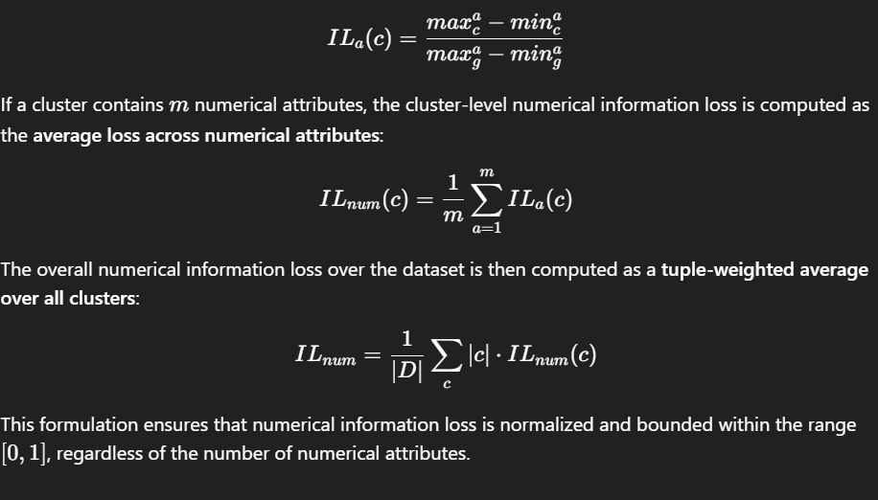

- Categorical information loss, quantified using Domain Generalization Hierarchies (DGHs) by measuring the proportion of leaf nodes subsumed by the generalized categorical values, and
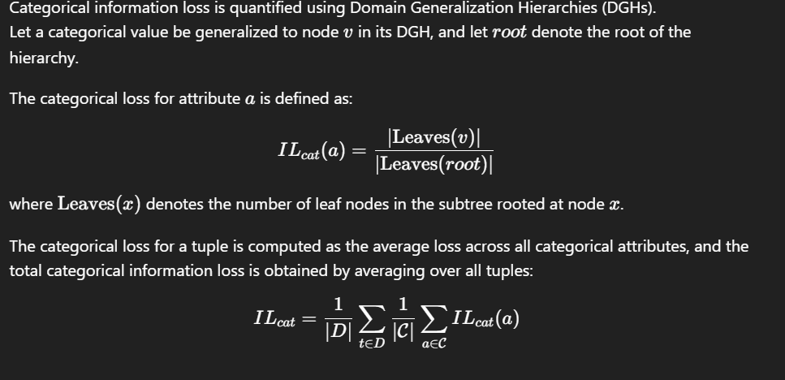
- Total information loss, obtained by combining numerical and categorical losses into a unified metric.
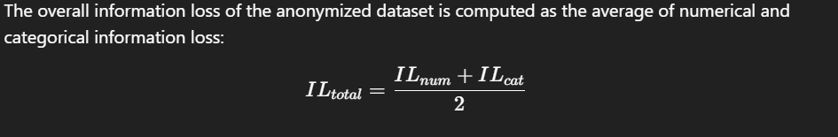
This definition offers a precise and semantically meaningful evaluation of the degradation of data, which can be compared to current methods of data anonymization in a fair and accurate manner.

4.5 Algorithms Used in the Proposed Approach
The proposed framework is implemented by a tightly coupled set of algorithms that work together for semantic-first clustering, controlled generalization, and utility-aware post-processing. Instead of using anonymization steps that are carried out independently, the algorithms are designed to work together as a single recursive pipeline, where clustering, generalization, and boundary detection are all optimized together.
To make things clearer, the roles of the algorithms are categorized based on their functionality in the framework.

4.5.1 Core Recursive Clustering Algorithm

Algorithm 1: Level-wise Semantic Cluster Generation
Input:
Dataset D, anonymity parameter k, DGH parent mappings, DGH roots, maximum generalization level maxLevel
Output:
k-anonymized dataset
Algorithm GenerateClusters(i, D, level)
1: if ( |D| − i ≤ k ) OR ( level = maxLevel ) then
2: U ← Algorithm 6: Extract unique categorical values from tuples [i … |D|−1]
3: L ← Algorithm 7: Compute LCA for each categorical attribute using U
4: Algorithm 8: Replace categorical values of tuples [i … |D|−1] with L
5: return
6: end if
7: Algorithm 2: Generalize categorical attributes of tuples [i … |D|−1] by one DGH level
8: H ← Algorithm 3: Construct semantic groups using categorical combinations
9: r ← Algorithm 4: Compute number of tuples that cannot form k-sized clusters
10: j ← |D| − r
11: Algorithm 5: Rearrange dataset to finalize clusters in range [i … j−1]
12: GenerateClusters(j, D, level + 1)
Algorithm 1 (GenerateClusters) is the main engine of the proposed method. It realizes a level-wise and semantic-first clustering approach based on a two-pointer technique and recursive control flow.
From the pointer i, the algorithm only considers the unfinalized part of the data while maintaining the previously formed clusters. At each step, the categorical attributes are generalized by exactly one level based on Domain Generalization Hierarchies (DGHs). The algorithm tries to establish semantic clusters at the current level of generalization before moving to higher levels.
The recursion stops when one of the following conditions is met:
1. The number of tuples left is less than the anonymity parameter k, or
2. The maximum DGH height is attained.
In both cases, a controlled fallback strategy based on Lowest Common Ancestors (LCAs) is used to guarantee correctness. This architecture ensures that overly strong generalization is postponed until it becomes absolutely necessary, which is a crucial difference to traditional top-down anonymization techniques.

4.5.2 Level-wise Categorical Generalization

Algorithm 2: Level-wise Categorical Generalization
Input:
Starting index i, dataset D, parent mappings from DGHs
Output:
Dataset generalized by one level
Algorithm GeneralizeCategorical(i, D)
1: for each tuple t in D from index i to |D|−1 do
2: for each categorical attribute c do
3: Replace value of c in t with its immediate DGH parent
4: end for
5: end for
Only unprocessed tuples are generalized, and finalized clusters are preserved.
Algorithm 2 (Generalise) carries out incremental categorical generalization based on immediate-parent mappings obtained from DGHs. Unlike global generalization methods, this algorithm generalizes only tuples beyond the current pointer i, leaving finalized clusters unchanged.
Each iteration replaces categorical attributes with their immediate parents, allowing:
• Fine control over semantic distortion
• Relaxation of clustering constraints
• Minimum information loss in the initial iterations
This index-aware generalization strategy is a cornerstone of the semantic-first approach of the framework.

4.5.3 Semantic Group Construction with Numerical Ordering

Algorithm 3: Semantic Group Construction
Input:
Starting index i, dataset D
Output:
HashMap of semantic groups
Algorithm ConstructSemanticGroups(i, D)
1: Initialize empty HashMap H
2: for each tuple t in D from index i to |D|−1 do
3: key ← concatenation of categorical attribute values of t
4: value ← numerical attributes of t with precomputed distance
5: Insert value into H[key] using a min-heap (PriorityQueue)
6: end for
7: return H
Semantic groups are created based on categorical combinations, while numerical tuples are ordered based on minimum deviation.
Algorithm 3 (ConstructHashMap) creates semantic groups based on a HashMap that is keyed based on ordered categorical attribute combinations. Each key is a unique representation of a semantic category at the current level of generalization.
For each semantic group, numerical attributes are stored in a PriorityQueue (min-heap) that is ordered based on a precomputed distance measure. This distance is the aggregated deviation of the numerical attributes from their domain minimum.
This approach satisfies two objectives simultaneously:
• Semantic purity based on categorical grouping
• Numerical utility preservation based on tuple ordering with minimal deviation in the numerical attributes during cluster formation
The combination of semantic hashing and numerical ordering is a unique aspect of the proposed solution.

4.5.4 Cluster Boundary Detection

Algorithm 4: Boundary Index Determination
Input:
Semantic group map H, anonymity parameter k
Output:
Boundary index j
Algorithm GetBoundaryIndex(H, k)
1: remainder ← 0
2: for each semantic group g in H do
3: remainder ← remainder + ( size(g) mod k )
4: end for
5: return remainder
This, in turn, determines the number of tuples that cannot yet form valid k-sized clusters.
Algorithm 4 (GetJIndex) computes the cluster boundary index j, which distinguishes finalized clusters from unresolved tuples.
Instead of scanning the data set sequentially, the algorithm examines the frequency of semantic groups by computing the number of tuples in each group that cannot form complete k-sized clusters. The aggregated remainder directly determines the number of tuples that must be deferred to the next iteration.
The frequency-aware boundary computation prevents unnecessary re-computation and facilitates efficient in-place cluster finalization.
Let r be the value returned by Algorithm 4, which represents the number of tuples that cannot form complete k-sized clusters at the current generalization level. The boundary index is then calculated as j=∣D∣−r. Tuples in the interval [i,j−1] can be finalized to form valid equivalence classes, and tuples in the interval [j,∣D∣−1] are deferred to the next generalization step.

4.5.5 In-place Semantic Cluster Formation

Algorithm 5: Dataset Rearrangement for Cluster Finalization
Input:
Starting index i, boundary index j, semantic group map H, dataset D, parameter k
Output:
Reordered dataset with finalized clusters

Algorithm RearrangeDataset(i, j, H, D, k)
1: Sort semantic groups in H by descending frequency
2: writeNormal ← i
3: writeOverflow ← j

4: for each semantic group g in sorted H do
5: normalCount ← size(g) − ( size(g) mod k )
6: while normalCount > 0 do
7: Extract tuple with minimum distance from g
8: Place tuple at D[writeNormal]
9: writeNormal ← writeNormal + 1
10: normalCount ← normalCount − 1
11: end while

12: while g is not empty do
13: Extract remaining tuple from g
14: Place tuple at D[writeOverflow]
15: writeOverflow ← writeOverflow + 1
16: end while
17: end for
The valid k-anonymous clusters are finalized first, and the remaining tuples are deferred.

Algorithm 5: ArrangeOriginalList rearranges the original dataset in-place according to semantic group frequencies. The semantic groups are processed in descending order of their sizes to achieve the largest possible number of early-formed clusters.
For each semantic group:
• Tuples that form complete k-blocks are written contiguously from pointer i
• Residual tuples are written after pointer j
This guarantees that:
• Indices [i,j−1] hold finalized semantic groups
• Indices [j,n−1] hold unresolved tuples for later processing
The application of two write pointers facilitates efficient clustering without requiring any data copies, which is important for the scalability of the framework.
4.5.6 Fallback Generalization Using Lowest Common Ancestors
For ease of reference, the pseudocode of Algorithms 6-14, dealing with fallback generalization, numerical post-processing, and information loss calculation, is given in the Appendix, whereas their purpose is described below.
Algorithms 6-8 are called only when sibling-based semantic clustering becomes impossible.
First, all remaining unique categorical values are gathered independently for each domain. Then, the Lowest Common Ancestor (LCA) of these values is calculated in the respective DGH. Finally, all remaining tuples are generalized to the LCA values.
This fallback strategy ensures k-anonymity in all termination cases while also ensuring that:
• LCA-based generalization is used only once
• Semantic degradation is minimized and localized

4.5.7 Numerical Attribute Generalization and Cleanup
Once the categorical clustering process is finished, Algorithm 9 carries out numerical generalization on each completed equivalence class. Numerical attributes are replaced with interval values [min,max] to preserve range information without allowing record correlation.
Algorithm 10 removes auxiliary computational attributes such as distance columns, ensuring that the released dataset contains only original quasi-identifiers.

4.5.8 Information Loss Evaluation
Algorithms 11-14 work together to calculate the information loss as follows:
• Numerical loss is measured as the width of the generalized intervals normalized to the global attribute value ranges.
• Categorical information loss is measured by the DGH leaf coverage, which reflects the semantic loss instead of the numeric distance.
• Total information loss is measured as the average of the numerical and categorical information loss.

4.6 Summary and Key Contributions
The algorithms described in this section, taken together, constitute a semantic-first, level-wise k-anonymization framework with a focus on categorical semantics, numerical utility, and scalability. The proposed framework is distinguished by its use of HashMap-based semantic clustering, PriorityQueue-supported numerical optimization, deferred LCA-based generalization, two-pointer technique-based in-place cluster formation, and DGH-aware information loss calculation. In contrast to traditional anonymization approaches that are based on strict partitioning or aggressive top-down generalization, the proposed framework is particularly suited to large datasets with a mix of attribute types due to its focus on semantic consistency and controlled generalization.
The major contributions of this research are summarized below:
1. Semantic-first clustering: This research presents the first k-anonymization approach that clusters tuples based on combinations of categorical attribute values instead of numerical proximity alone.
2. Sibling-first, level-wise generalization: Categorical attributes are generalized level by level based on sibling information in DGHs, resulting in a significant reduction in the loss of categorical information.
3. Early termination for utility preservation: The generalization process is terminated as soon as valid semantic clusters are obtained, avoiding unnecessary generalization to higher levels of DGHs.
4. Joint categorical and numerical optimization: Semantic clustering of categorical attributes is combined with numerical proximity optimization within clusters using PriorityQueues.
5. Scalability and efficiency: The approach can handle datasets of up to 10^6 tuples and has an overall time complexity of O(nlogn) due to the use of bounded recursion, HashMaps, PriorityQueues, and a two-pointer technique.
4.7 Time Complexity Analysis
This section will analyze the computational complexity of the proposed level-wise semantic clustering framework. Here, n is the total number of tuples in the dataset, k is the anonymity parameter, and maxlevel is the maximum height of all categorical Domain Generalization Hierarchies (DGHs).
- Recursion Depth Analysis
Algorithm 1 (generateClusters) is a recursive algorithm that carries out level-wise generalization of categorical attributes. The recursion is limited by maxlevel, which is the maximum generalization level of the categorical DGHs. The heights of the DGHs are constants that are not dependent on the size of the dataset, and hence maxlevel is also a constant.
The recursive algorithm will therefore run at most maxlevel times, and the time complexity is proportional to the cost of running the algorithm once.
- Per-Iteration Complexity Analysis
In every iteration of Algorithm 1, the following algorithms run:
1) Algorithm 2: Immediate Parent Generalization
Algorithm 2 performs the generalization of the categorical attributes of tuples from index i to n − 1 by assigning each categorical attribute its immediate parent based on precomputed parent maps.
• Every tuple is visited once.
• The lookup of the parent of every categorical attribute takes O(1) time.
Time Complexity:
O(n−i) ⊆ O(n)
2)Algorithm 3: HashMap Construction
Algorithm 3 iterates through tuples from index i to n − 1 and builds a HashMap such that:
• Each tuple corresponds to exactly one key-value pair.
• Building keys and adding them to the HashMap takes constant time.
• Each tuple is added once to a PriorityQueue.
Time Complexity:
O(n−I ) ⊆ O(n)

3)Algorithm 4: Boundary Index Computation
Algorithm 4 iterates through the HashMap to calculate the boundary index j within the constraints of cluster sizes.
• The number of HashMap entries is limited by (n − i).
• Each entry is processed once.
Time Complexity:
O(n−i) ⊆ O(n)
4)Algorithm 5: Arrangement of Tuples
Algorithm 5 involves two primary steps:
1. Sorting HashMap entries according to frequency (PriorityQueue size), and
2. Organizing tuples by polling from PriorityQueues.
Sorting the HashMap entries takes:
O(m log m),where m ≤ (n−i)
Polling and adding tuples to the original list takes a logarithmic amount of time per operation because of the PriorityQueue.
Total Time Complexity:
O((n − i) log(n - i) ) ⊆ O(n logn)

Total Cost per Iteration
Adding the costs of Algorithms 2 through 5:
O(n) + O(n) + O(n) + O(nlogn) = O(nlogn)
As the dominant term is O(nlogn), the cost of one iteration of Algorithm 1 is: O(nlogn)

Overall Time Complexity
As established earlier, Algorithm 1 executes for at most maxlevel iterations, where maxlevel is constant. Therefore, the total time complexity of the proposed framework is:
O(maxlevel × nlogn) = O(nlogn)

Base Case Handling Complexity
When the base condition (n−i) ≤ k or level = maxlevel is attained, Algorithms 6-8 are invoked. These algorithms carry out the following tasks:
• Obtaining the distinct categorical values,
• Calculation of the Lowest Common Ancestor (LCA), and
• Value replacement.
Each of these tasks linearly processes the remaining tuples.
Time Complexity:
O(n−i) ⊆ O(n)
This is only done once when the algorithm terminates. It doesn’t impact the overall complexity.

Scalability Discussion
For big data, if n = 10^5 or n = 10^6, the quadratic time complexity algorithms (O(n^2)) would take approximately 10^10 to 10^12 operations, which is computationally impractical.
On the other hand, the proposed framework takes O(nlogn) time complexity. Even for n = 10^6, this would take approximately:
106× log2(106) ≈ 2×107
operations, which is quite feasible. This theoretical explanation is also supported by the experimental findings discussed in the Results and Performance Evaluation section.
The proposed method is able to provide efficient and scalable semantic k-anonymization through the effective combination of level-wise generalization and optimized data structures. The application of HashMaps, PriorityQueues, two-pointer methods, and bounded recursion helps the framework handle large data efficiently with low information loss and feasible runtime performance.

- Complexity Summary
The proposed framework is able to achieve efficient and scalable semantic k-anonymization by integrating level-wise generalization and optimized data structures. The application of HashMaps, PriorityQueues, two-pointer techniques, and bounded recursion helps the framework scale to larger datasets with low information loss and reasonable runtime efficiency.

4.8 Overall Summary
This paper proposes a new semantic clustering-based k-anonymization framework that takes a clear semantic priority in a privacy-constrained setting. By creating semantic clusters based on combinations of categorical attributes and then generalizing numerical attributes within these clusters, the proposed approach is able to generate k-anonymized datasets that are both semantically interpretable and utility-preserving. The proposed framework is particularly suitable for real-world data publishing and large-scale privacy-preserving data analysis tasks due to its semantic-first design, controlled generalization, and scalability.

